**PRANALI PAWAR**

**Topic: facebook login page**

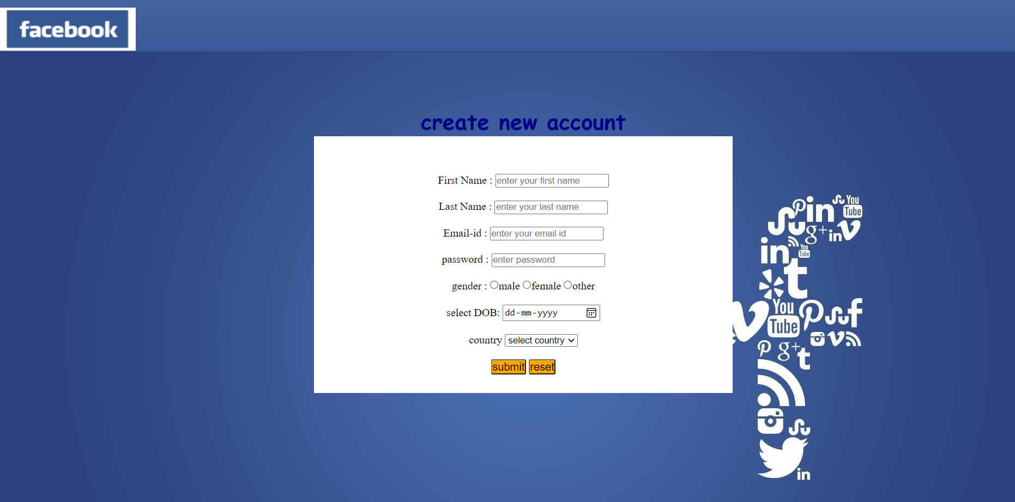

**Topic : instagram login page**

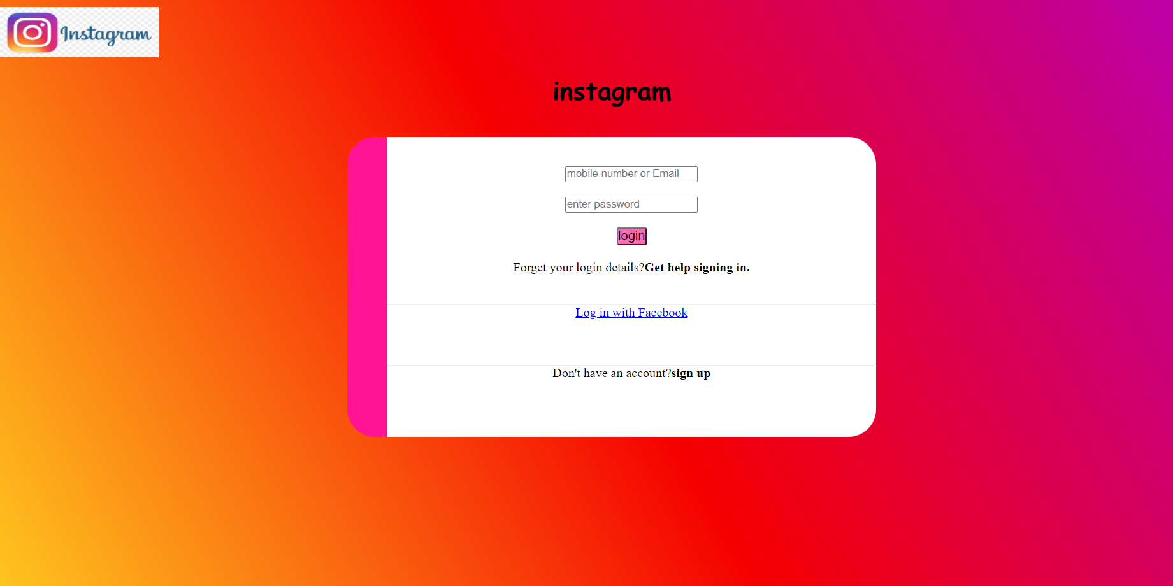

**Topic : student login page**

